NAVSEA Std. Item 009-07
lists an alternate procedure
to pulling back fuel gas & oxygen hoses from enclosed spaces.
BHISD - Approved Procedure

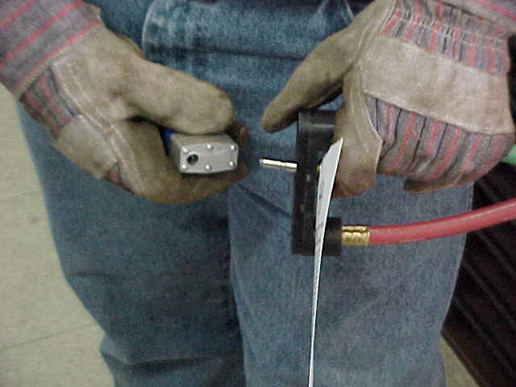

Each package comes with two BHISDs
(a pair), two locks with matching keys,
and two tags.

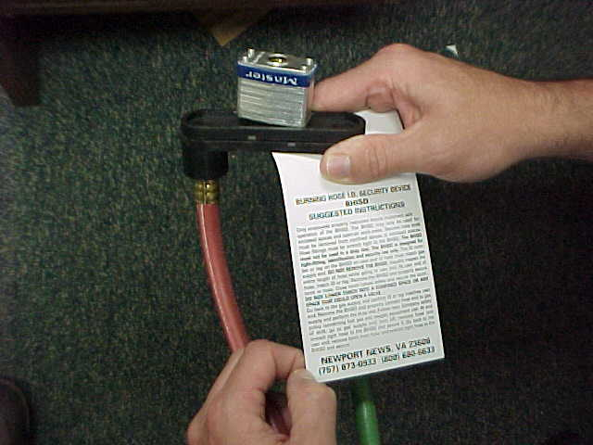

The tags have a brief description on how
to use the BHISD, as a reminder to users.

For more information on BHISD, please visit www.bhisd.com

Marine Chemist Service, Inc.
11850 Tug Boat Lane
Newport News, VA 23606
PH: (757) 873-0933
FAX: (757) 873-1074
www.marinechemist.com

Burning Hose ID
and
Security Device
(BHISD)

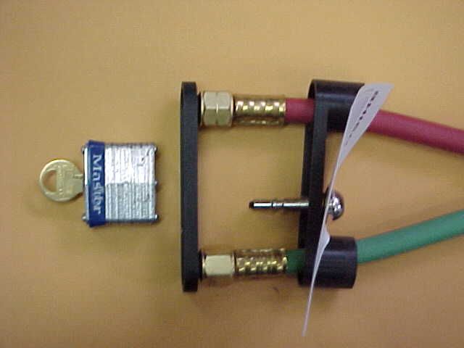

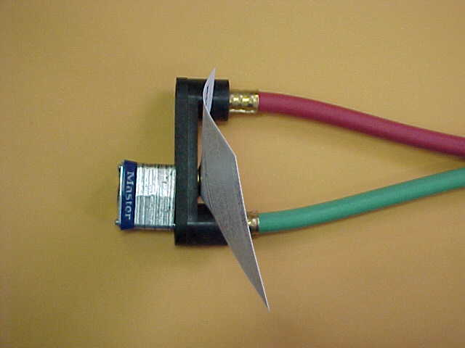

Save time and money

when using the BHISD

MCS’s Burning Hose ID and Security Device (BHISD) offers positive identification and secure connection to complement your fuel gas and oxygen safety needs.

Hot work operators can rely on the BHISD to prevent unauthorized use and accidental connection to wrong ends, thereby eliminating gas discharging into a space. The BHISD is also used to positively identify both ends of a burning hose.
.
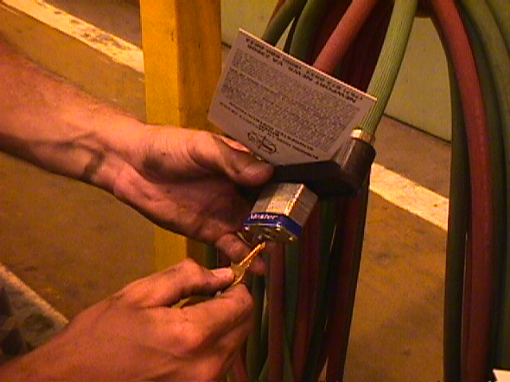

.
The BHISD should be used on all operations involving the use of fuel gas and oxygen. Proper use of the BHISD will allow fuel gas and oxygen hoses to be left in enclosed spaces with assurance that neither employees, contractors, nor customers will be able to use the equipment without proper authority and instruction.

Some of the safety features include the impossibility of employees hooking to wrong ends and possibly charging burning hoses, which could result in fuel gas and/or oxygen entering a space. BHISD’s have a pair of locks that come with four keys keyed alike. Only the employee who has been assigned a BHISD can access their device. A single shank lock prevents the use of another lock.
BHISD Features

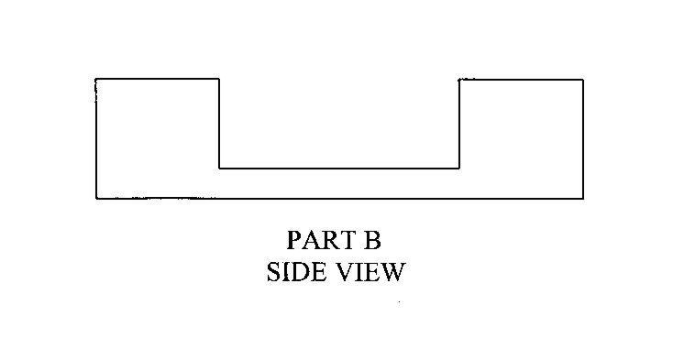

Part B, the hasp end, slides over the hose and hose coupling ends, preventing unauthorized use.
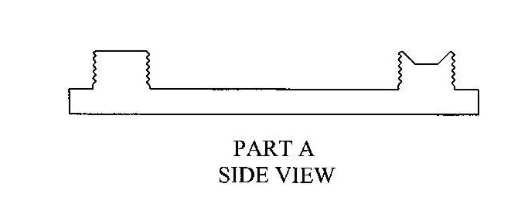

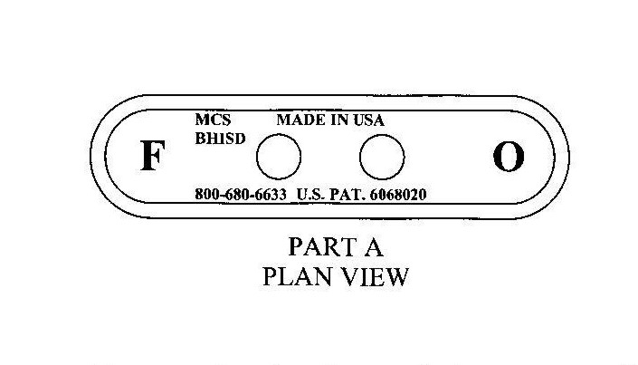
Part A, the blank end, with threads and seats, for hose connections.

The underside of Part A has a “F” for fuel gas connection and an “O” for oxygen connection. “F” is printed under the left handed threads and “O” under the right handed threads.

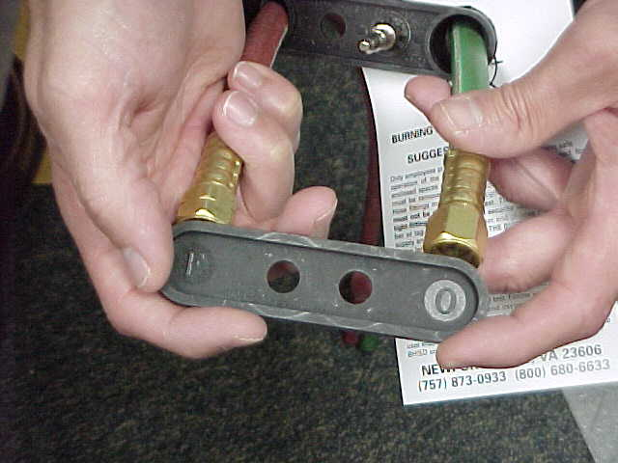

BHISD is made of ISOPLAST, an Engineering Polyurethane Resin by The DOW Chemical Co.
Each BHISD has a tag attached to inform others where the hose is routed to, who is using it, and their ID number.
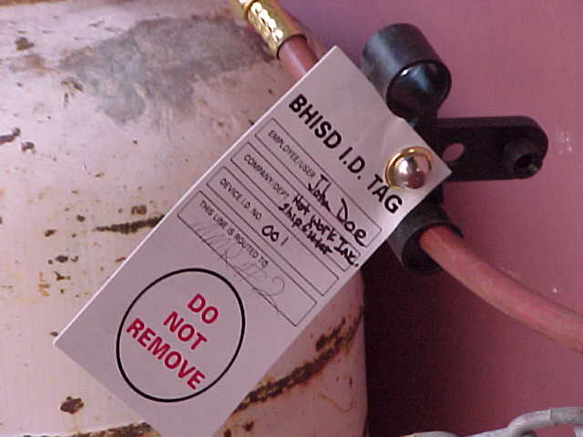

Only employees properly instructed should implement safe operation of the BHISD, fuel gas and oxygen equipment. The BHISD may only be used for enclosed spaces and open-air work areas. Secured hose ends must be removed from confined spaces to enclosed spaces. Hose fittings must be wrench tight to the BHISD. The BHISD must not be used in a drop test. The BHISD is designed for tight fitting, identification and security use only. The ID number or tag on the BHISD user end of hose must match gas supply end. During start of shift, inspect the BHISD and ID or tag at supply end. DO NOT REMOVE THE BHISD. Visually inspect entire length of hose while going to user end. At user end of hose, match ID or tag. Remove the BHISD and properly secure torch to hose. Close torch valves and safely secure the torch. DO NOT LOWER TORCH INTO A CONFINED SPACE OR ANY SPACE THAT COULD OPEN A VALVE.

SAMPLE TAG FRONT
Go back to the gas supply and confirm ID or tag matches user end. Remove the BHISD and properly connect hose end to gas supply. Perform the drop test. Follow your Company’s safety policy concerning fuel gas and oxygen equipment use. At end of shift, go to gas supply end and turn off. Remove hose and wrench tight hose to the BHISD to secure it. Go back to the user end, remove torch from hose and wrench tight hose to the BHISD to secure it.

Name: MR. SAMPLE
Identification No.:
This fuel gas and oxygen hose is routed to:__________________________
_____________________________________________________________
Marine Chemist Service, Inc. Newport News, Va. 23606
(757) 873-0933 or 800-680-6633

SAMPLE TAG BACK

